Australian Clinical Trials — Regulatory Register
Oct 21, 2026 · @Peter

How to read this register
Australia has no single clinical-trials statute. A trial runs under a stack: Commonwealth therapeutic-goods law (only where an unapproved good is supplied), ICH GCP incorporated into that law by reference, NHMRC ethics guidelines applied by HRECs, site governance run by each state health system and the NCTGF, and specialist regimes triggered by what the trial uses.
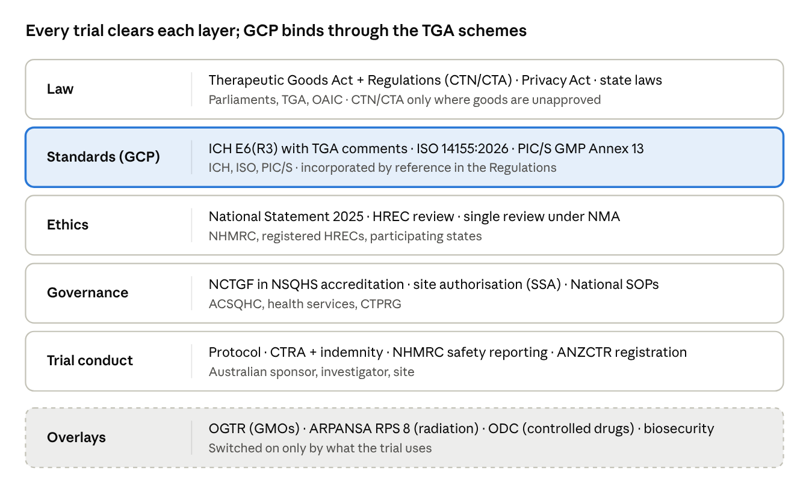
regulatory stack · 5 layers + overlays
Read top down: each layer must be satisfied; overlays apply only when the trial triggers them.
The TGA regulates the goods, not the trial end to end. Every trial needs HREC approval and site authorisation; only trials of unapproved goods also need a CTN or CTA. Where the National Statement and ICH GCP appear to differ, the TGA says the National Statement takes precedence.
Status words used below: In force (applies now) · Transition (new version in force, old one still accepted) · Consultation (draft out) · Planned (announced, not built). Scope is human trials of medicines, biologicals and devices, plus the interventional health research that shares the same ethics and governance machinery.

Regulators, agencies and policy bodies
The TGA and NHMRC are the two load-bearing national bodies; the Department of Health, Disability and Ageing (DHDA) drives the reform agenda through IGPRG and CTPRG.
Body | Type | Role in clinical trials
Therapeutic Goods Administration (TGA) | Commonwealth regulator (within DHDA) | Runs the CTN and CTA schemes for unapproved goods; adopts and annotates ICH GCP; GCP Inspection Program of investigator sites; safety reports (SUSARs, device SAEs)
National Health and Medical Research Council (NHMRC) | Commonwealth statutory body | Issues the National Statement (with ARC, UA); safety monitoring guidance; s95/95A privacy guidelines; registers HRECs and certifies institutional ethics review processes
Australian Health Ethics Committee (AHEC) | NHMRC principal committee | Drafts and revises the National Statement
Australian Commission on Safety and Quality in Health Care (ACSQHC) | Commonwealth-state agency | Owns the National Clinical Trials Governance Framework and NSQHS Standards used to accredit health services for trials
Department of Health, Disability and Ageing (DHDA) | Commonwealth department | Leads national reforms (NOSS, National SOPs, ethics accreditation); hosts the Australian Clinical Trials website
Inter-Governmental Policy Reform Group (IGPRG) | Cross-jurisdiction group, chaired by Prof Ian Chubb | Steers NOSS, single ethics review and NCTGF implementation
Clinical Trials Project Reference Group (CTPRG) | Health ministers' working group | Owns the National SOPs and National Principles for Teletrials
Health Human Research Ethics Committees (HRECs) | Institutional, NHMRC-registered | Ethical and scientific review; decide CTN vs CTA with the sponsor
Research governance offices (RGOs) | Each health service | Site-specific assessment (SSA) and authorisation to start
Office of the Gene Technology Regulator (OGTR) | Commonwealth regulator | Licenses dealings with GMOs (DIR/DNIR) in trials
ARPANSA + state radiation regulators | Commonwealth agency + state licensing | Research exposure code (RPS 8); state Acts adopt it
Office of Drug Control (ODC) | Commonwealth (DHDA) | Import/export licences and permits for narcotic and psychotropic IMPs
Office of the Australian Information Commissioner (OAIC) | Commonwealth regulator | Approves NHMRC's s95/95A/95AA guidelines; Privacy Act enforcement
Australian Research Integrity Committee (ARIC) | NHMRC + ARC joint | Reviews how institutions handled alleged breaches of the Australian Code
Department of Agriculture, Fisheries and Forestry (DAFF) | Commonwealth | Import permits for biological material (samples, tissues)
State/territory health departments and tribunals (e.g. NCAT, VCAT) | State | Ethics/governance systems, NMA, substitute-consent approvals

Commonwealth legislation and instruments
The CTN and CTA schemes are exemptions from the Therapeutic Goods Act's registration requirement, not a licence to run a trial; the conditions attached to those exemptions are where GCP becomes law.
Instrument | Status | What it does for trials
Therapeutic Goods Act 1989 | In force | CTN exemption via s18(1), 32CA(2) and 41HA; CTA approval via s19(1)(b) and equivalents for devices and biologicals
Therapeutic Goods Regulations 1990 | In force | Sch 5A item 3 (CTN); reg 12AD conditions, incl. use in line with ICH GCP and the National Statement; incorporates the GCP guideline by reference
Therapeutic Goods (Medical Devices) Regulations 2002 | In force | Sch 4 item 2.3 (device CTN); reg 7.5 conditions for device trials
Therapeutic Goods (Clinical Trial Notification Form) Approval 2024 | In force | Approves the current online CTN form
Therapeutic Goods (Clinical Trials Inspections) Specification (No. 2) 2020 | In force | Legal basis for TGA GCP inspections of sites
National Health and Medical Research Council Act 1992 (and NHMRC Regulation 2016) | In force | Basis for the National Statement and other NHMRC guidelines; consultation duties on changes
Privacy Act 1988 (APPs; s95, 95A, 95AA) | In force | Health information handling; research use without consent only under NHMRC guidelines approved by the Commissioner
Gene Technology Act 2000 + Gene Technology Regulations 2001 | In force | Licences for trials that involve dealings with GMOs
Customs (Prohibited Imports) Regulations 1956 (reg 5) + Narcotic Drugs Act 1967 | In force | Licence and per-shipment permit to import controlled IMPs
Biosecurity Act 2015 | In force | Import conditions for biological material
Australian Radiation Protection and Nuclear Safety Act 1998 | In force | Basis for ARPANSA codes, incl. RPS 8
Poisons Standard (SUSMP), under the Therapeutic Goods Act | In force | Scheduling that drives state storage, handling and prescribing rules for IMPs
Medical Research Future Fund Act 2015 | In force | Funding source for many investigator-led trials
Industry Research and Development Act 1986 / Income Tax Assessment Act 1997 (R&D Tax Incentive) | In force | Sponsor incentive that shapes where trials are placed

GCP and international standards
Australia is mid-transition: ICH E6(R3) with TGA comments took effect on 13 January 2026, and E6(R2) stops being acceptable for CTN/CTA trials on 13 January 2027. Device trials follow ISO 14155, itself in a transition to the 2026 edition until 31 March 2027.
Standard | Issuer | Status in Australia (Oct 2026) | Notes
ICH E6(R3) GCP: Principles and Annex 1, with TGA comments | ICH; adopted by TGA | Transition: effective 13 Jan 2026; either R2 or R3 until 13 Jan 2027 | Incorporated into law without modification by reference in the Regulations; TGA comments map Australian requirements (Australian sponsor accountable; applicable GMP = PIC/S Annex 13)
ICH E6(R2) integrated addendum | ICH | Superseded; acceptable until 13 Jan 2027 | Many site SOPs still reference it
ICH E6(R3) Annex 2 (decentralised, pragmatic, real-world data) | ICH | Step 4 on 3 Jun 2026; TGA adoption pending its consultation process | EU effective 15 Jan 2027; relevant to teletrials
ISO 14155:2026 Clinical investigation of medical devices: GCP | ISO | Transition: 31 Mar 2026 to 31 Mar 2027 | The GCP standard for device CTN/CTA trials
ICH E8(R1) General considerations for clinical studies | ICH; adopted by TGA | In force | TGA notes compliance is not itself a CTN/CTA condition
ICH E2A Clinical safety data management: expedited reporting | ICH; adopted by TGA in principle | In force | Source of expedited reporting timeframes
ICH E2F Development Safety Update Report | ICH | In force | Referenced by NHMRC safety guidance for annual safety reports
ICH M11 CeSHarP structured protocol template + technical spec | ICH | Step 4 on 19 Nov 2025; TGA adoption not confirmed | Becoming the default protocol structure for multinational sponsors
Other ICH efficacy guidelines (E9 statistics, E11 paediatrics, E17 multi-regional trials) | ICH; adopted by TGA | In force | Listed on TGA's international guidelines page
PIC/S Guide to GMP, Annex 13 (investigational products) | PIC/S; adopted by TGA | In force | The "applicable GMP" for IMPs
Australian Code of GMP for blood, tissues and cellular therapy products | TGA | In force | Applicable GMP for biologicals
WMA Declaration of Helsinki (2024 revision) | World Medical Association | In force (ethical) | Referenced by the National SOPs revision
CIOMS International Ethical Guidelines (2016) | CIOMS / WHO | Reference | Commonly cited by HRECs

Ethics, integrity and privacy guidance
The National Statement 2025 has been the operative edition since 23 June 2026, replacing the 2023 edition; its rewritten Section 4 shifts from excluding "vulnerable" groups to risk-proportionate inclusion.
Document | Issuer | Status (Oct 2026) | Role
National Statement on Ethical Conduct in Human Research (2025) | NHMRC, ARC, Universities Australia | In force from 23 Jun 2026 | The standard every HREC applies; Section 3 covers research design, review and conduct (including trials), Section 4 participant groups, Section 5 review processes
Human Research Ethics Application (HREA) v1.6 | NHMRC | In force | National application form, updated to align with the 2025 Statement
Australian Code for the Responsible Conduct of Research (2018) + Guide to Managing and Investigating Potential Breaches | NHMRC, ARC, Universities Australia | In force; a review is signalled after the Feb 2026 ARC–NHMRC joint statement | Integrity, data retention, authorship, breach handling; a condition of NHMRC/ARC funding
Guidelines under s95 of the Privacy Act 1988 (2014, updated 2024) | NHMRC, approved by the Information Commissioner | In force | Use of Commonwealth-agency data for medical research without consent
Guidelines approved under s95A (2014, updated 2024) | NHMRC, approved by the Information Commissioner | In force; OAIC reviewing the approvals | HREC framework for private-sector health information without consent
Guidelines under s95AA (genetic information) | NHMRC, approved by the Information Commissioner | In force | Disclosure of genetic information to genetic relatives
Ethical conduct in research with Aboriginal and Torres Strait Islander Peoples and communities (2018) | NHMRC | In force | Now a required consideration under the 2025 Statement's Chapter 4.7
AIATSIS Code of Ethics for Aboriginal and Torres Strait Islander Research (2020) | AIATSIS | In force | Specified resources named in the 2025 Statement

TGA operational guidance and safety reporting
The Australian Clinical Trial Handbook is the TGA's plain-English map of the legislation; safety reporting runs on NHMRC's 2016 guidance and its three supplements.
Document | Issuer | Status | Role
Australian Clinical Trial Handbook | TGA | In force (living web guidance; CTX renamed CTA) | Sponsor, HREC, investigator and institution roles; when goods are "unapproved"; manufacture and import of trial goods
Clinical Trial Notification (CTN) scheme page + CTN form user guide | TGA | In force | Online notification by the Australian sponsor via TGA Business Services; fee paid before supply
Clinical Trial Approval (CTA) scheme guidance | TGA | In force; scheme under review | TGA evaluates data before the trial; mandatory for Class 4 biologicals (with exceptions)
Investigator's brochures for medical device clinical trials | TGA | In force | Content expectations for device IBs
GCP inspection program guidance | TGA | In force (revised Apr 2026) | What site inspections cover; medicines, biologicals and devices; sponsors and HRECs out of scope
GCP Inspection Program Metrics Report 2025 | TGA | Published 2026 | Inspection findings to calibrate site QA
Proactive monitoring of highest-risk device first-in-human trials | TGA | In force | TGA review of safety data behind high-risk device CTNs
Safety monitoring and reporting in clinical trials involving therapeutic goods (2016) | NHMRC | In force | Who reports what (SAEs, SUSARs, USMs, SSIs) to whom and when, for CTN/CTA trials; broadly applied to all trials
Supplement: Data Safety Monitoring Boards | NHMRC | In force | When a DSMB is needed and how it works
Supplement: Risk-based management and monitoring of clinical trials (2018) | NHMRC | In force | Risk-proportionate monitoring plans
Supplement: Reporting of serious breaches of GCP or the protocol | NHMRC | In force | Serious-breach definition and reporting path; read with the Australian Code

Site governance and national operating frameworks
Ethics approval and permission to start are separate steps: an NMA-accepted HREC approval still needs site authorisation at every site, and hospitals are now accredited on how they govern trials.
Framework | Owner | Status (Oct 2026) | Role
National Clinical Trials Governance Framework (NCTGF) (2022) | ACSQHC for all jurisdictions | In force; assessed through health-service accreditation | Embeds trial governance in NSQHS Standards 1 (clinical governance) and 2 (partnering with consumers)
NSQHS Standards (third edition) | ACSQHC | Consultation closed 25 Sep 2026 | Draft folds the NCTGF in and widens the focus to clinical research generally
National Mutual Acceptance (NMA) — MOU, Standard Principles for Operation, ethics and governance matrix | Participating states and territories | In force; NT and Tasmania the latest to join | One NHMRC-certified HREC review accepted across public health organisations; Phase 0/I and some early-phase trials excluded in some states (e.g. NSW, SA)
NHMRC certification of institutional ethics review processes | NHMRC | In force | Which HRECs can act as single reviewers under NMA
National SOPs for Clinical Trials in Australia | CTPRG / DHDA | Revised edition (consultation closed Jun 2026) | Minimum standards for public and private sites; teletrial principles integrated; new SOP 14 on data management; aligned to E6(R3), 2025 Statement, Helsinki 2024
National Principles for Teletrials in Australia | CTPRG | In force | Primary and satellite site model (Australasian Teletrial Model, COSA)
Site-specific assessment (SSA) forms and state ethics/governance portals | Each state | In force | Local authorisation; see the state layer below

Specialist regimes
These switch on by what the trial uses, and each runs its own approval in parallel with ethics and the TGA.
Trigger | Regime | Approval needed
GMO in the product (gene therapies, GM viruses or bacteria) | OGTR guidance for human clinical trials involving GMOs under the Gene Technology Act 2000 | DIR licence ("limited and controlled" release) or DNIR; one licence can cover several sites
Extra ionising radiation beyond standard care | ARPANSA RPS 8: Code of Practice for Exposure of Humans to Ionizing Radiation for Research Purposes (2005); ARPANSA C-5 Medical Exposure Code; 2020 ARPANSA trials statement | Medical physicist dose and risk report to the HREC; adopted into state law (e.g. NSW Radiation Control Act)
Narcotic or psychotropic IMP (e.g. psychedelic trials) | ODC import licence and permit under Customs (Prohibited Imports) Regulations reg 5; state poisons/controlled-substances licences | Licence plus a permit per shipment, citing the CTN/CTA
Imported biological material or samples | Biosecurity Act 2015 import conditions | Import permit where conditions require
Manufacture of IMPs | PIC/S GMP Annex 13; Australian GMP code for biologicals | Manufacturer GMP evidence; TGA licence where Australian manufacture applies
Adults lacking capacity to consent | State guardianship and medical-treatment laws (state layer below) | Substitute consent or tribunal approval, varying by state

State and territory layer
Consent for adults who cannot consent is the sharpest state difference: NSW needs tribunal approval of the trial itself, Victoria uses a medical treatment decision-maker, and the rest vary. The best single cross-check is the NSW OHMR Jurisdictional Legislative Requirements matrix (Dec 2023).
Jurisdiction | Ethics / governance system | Adults lacking capacity | Health records law
VIC | ERM, with the Victorian Specific Module | Medical Treatment Planning and Decisions Act 2016 (medical research procedures) | Health Records Act 2001 + Statutory Guidelines on Research
NSW | REGIS | Guardianship Act 1987 Pt 5: NCAT approves the trial (s45AA), then substitute consent | Health Records and Information Privacy Act 2002 + statutory research guidelines
QLD | ERM | Guardianship and Administration Act 2000 | Information Privacy Act 2009
WA | Research Governance Service (RGS) | Guardianship and Administration Act 1990 | No dedicated health records Act
SA | SA Health ethics and governance process | Consent to Medical Treatment and Palliative Care Act 1995; Advance Care Directives Act 2013 | Administrative privacy principles
TAS | State process (NMA participant) | Guardianship and Administration Act 1995 | Personal Information Protection Act 2004
ACT | ACT Health process | Guardianship and Management of Property Act 1991 | Health Records (Privacy and Access) Act 1997
NT | State process (NMA participant) | Guardianship of Adults Act 2016; Advance Personal Planning Act 2013 | Information Act 2002
Also state-level: poisons and controlled-substances Acts (storage, supply of scheduled IMPs), radiation control Acts (adopting RPS 8), and each health department's research governance policy. Check WA and QLD section references against the matrix before relying on them; WA's position on substitute research consent has changed since 2020.

Registries, contracts, indemnity and sector bodies
Medicines Australia's standard CTRAs are the de facto contract set; HRECs typically require indemnity no less favourable than the Medicines Australia form.
Registries and transparency
Item | Owner | Role
Australian New Zealand Clinical Trials Registry (ANZCTR) | NHMRC Clinical Trials Centre, Univ. of Sydney | WHO primary registry; to become a core component of NOSS
ClinicalTrials.gov / WHO ICTRP | US NLM / WHO | Alternative or parallel registration for multinational trials
Australian Clinical Trials website | DHDA | Public trial information, reform news, national SOPs
Contracts, indemnity and insurance
Template | Issuer | Use
CTRA — Medicines Australia Standard Form | Medicines Australia | Commercial sponsor and institution
CTRA — CRO acting as Local Sponsor | Medicines Australia | CRO as Australian sponsor
CTRA — Phase 4 (medicines), and Phase 4 CRO variant | Medicines Australia | Post-marketing trials
CTRA — Collaborative or Cooperative Research Group (CRG) studies | Medicines Australia | Investigator-led and cooperative-group trials
Form of Indemnity for Clinical Trials — Standard and HREC Review Only | Medicines Australia | Sponsor indemnifies institution and HREC
Compensation Guidelines for Clinical Trials | Medicines Australia | Participant injury compensation principles
Clinical Investigation Research Agreement (CIRA) + standard indemnity | Medical Technology Association of Australia (MTAA) | Device trial equivalents
State insurer clinical trial guidelines (e.g. VMIA) | State insurers | Public-site insurance requirements
Sector and peak bodies (no regulatory force, but shape practice): Australian Clinical Trials Alliance (ACTA), Medicines Australia, MTAA, AusBiotech, ARCS Australia, COSA (teletrial model), MTPConnect, Clinical Trials Centre (Univ. of Sydney), Australian Teletrial Program (Queensland Health national office).

Reform watchlist (as at October 2026)
The next hard deadline is 13 January 2027, when E6(R2) stops being acceptable for CTN/CTA trials; ISO 14155:2026 becomes the only device standard on 31 March 2027.
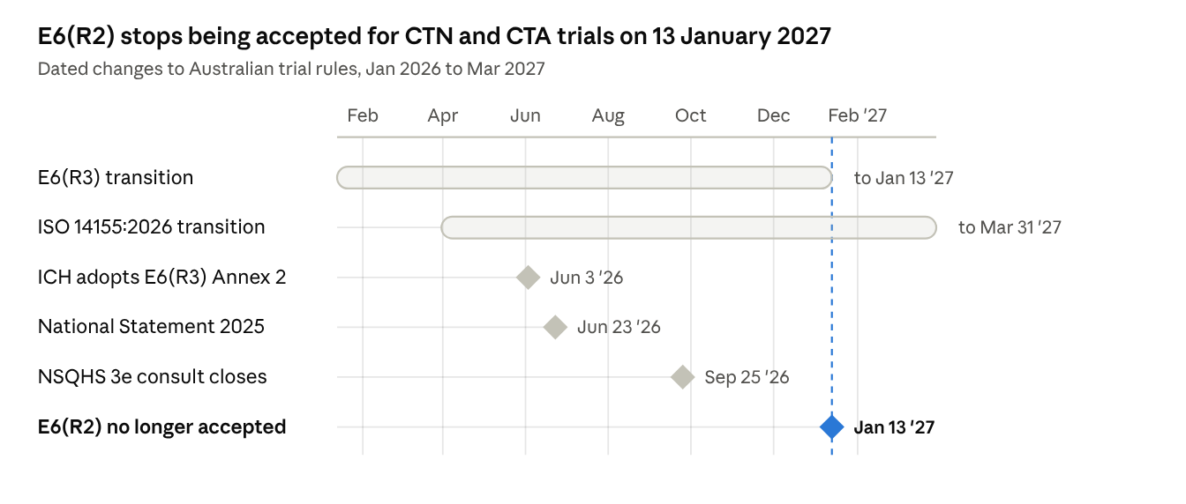
dated changes · Jan 2026 to Mar 2027
Undated items still in flight:
- National One Stop Shop (NOSS) — single national platform for ethics, site authorisation, TGA notification, registration and safety reporting, with an embedded registry absorbing ANZCTR. Funded in the 2026–27 Budget; solution partner being appointed; build expected to take 18+ months after appointment. (IGPRG, Aug 2026)
- Single ethics review and HREC accreditation — draft accreditation standards consulted in 2025; a design delivery partner is to be appointed.
- TGA adoption of ICH E6(R3) Annex 2 — to go through TGA's standard consultation; no Australian date yet.
- NSQHS Standards third edition — draft folding in the NCTGF; consultation closed 25 Sep 2026, final edition pending.
- CTA scheme review — TGA consulted HRECs in 2024 on options; outcome not yet reflected in the Handbook.
- Privacy guidelines — OAIC reviewing its approval of the s95/95A/95AA guidelines.
- Australian Code for the Responsible Conduct of Research — review signalled by the Feb 2026 ARC–NHMRC joint statement.
- National Health and Medical Research Strategy 2026–2036 (released May 2026) and the draft MRFF Strategy 2026–31 shape funding priorities.

Sources
Checked 21 October 2026. Primary sources first; secondary commentary used only for dates not yet on a regulator's page.
- TGA — ICH Guideline for Good Clinical Practice (E6(R3) with TGA comments)
- TGA — ICH E6(R3) adoption record
- TGA — Australian Clinical Trial Handbook
- TGA — CTN scheme
- TGA — Preparing for GCP inspections
- TGA — CTA scheme HREC consultation (Apr 2024)
- NHMRC — National Statement 2025 and 2025 update FAQs
- MinterEllison — National Statement now in effect (23 Jun 2026)
- NHMRC — Safety monitoring and reporting guidance
- NHMRC — s95A guidelines (2024); s95 explanatory statement (F2024L00463)
- OAIC — Health and medical research; OAIC guidelines review
- ACSQHC — Clinical Trials portal (NCTGF)
- DHDA — IGPRG newsletter, Aug 2026; May 2026
- Australian Clinical Trials — NOSS; National SOPs; National SOPs consultation
- Victoria — National Mutual Acceptance; consent laws for adults without capacity (Mar 2024)
- NSW OHMR — Jurisdictional Legislative Requirements (Dec 2023)
- OGTR — Guidance for human clinical trials involving GMOs
- ARPANSA — RPS 8 Code of Practice
- ODC — Import permits for narcotic and psychotropic substances
- ANZCTR — Progress towards NOSS
- King & Wood Mallesons — Navigating Australia's clinical trial landscape, Part 3
- ICH E6(R3) Annex 2 adoption (Becaris); ICH M11 template (FDA copy)
- ARC — Research integrity and Feb 2026 joint statement

